Task: ETL pipeline
Name: Aleke James-669116

- Business structure, requirement and purpose
The retail company operates through three sales channels:
. physical stores
. an online platform,
. third-party partners.
Each channel stores sales data in different formats (CSV, JSON, and Excel). This fragmentation prevents integrated reporting and consistent analysis.
The purpose of the data warehouse is to centralize and integrate all sales data into PostgreSQL to support analytical queries such as revenue trends, product performance, and channel comparison.
- Identify, extract and transform the data sources.
- Data sources identified include:
• Physical store data (CSV)
• Online platform data (JSON)
• Partner sales data (Excel)
• Product master data (PostgreSQL)
- Extraction was performed using pgAdmin Import/Export tool. All raw data was loaded into staging tables before transformation.
- Transformations included:
i. Converting text dates to data format

INSERT INTO dim_date (full_date, day, month, year)
SELECT DISTINCT
CAST(orderdate AS DATE),
EXTRACT(DAY FROM CAST(orderdate AS DATE)),
EXTRACT(MONTH FROM CAST(orderdate AS DATE)),
EXTRACT(YEAR FROM CAST(orderdate AS DATE))
FROM staging_store_sales;
ii. Standardizing column names
- standardized attribute names were adopted in the dimensional model to ensure consistency across channels.
dim_date.full_date
.
iii. Aligning schemas for dimensional modeling
- The wide transactional schema in the staging layer was decomposed into separate dimension and fact tables. Product, customer, and time attributes were isolated into dimension tables, while quantitative measures were stored in the fact table, aligning the schema with Kimball dimensional modeling principles.

fact_sales
dim_date
dim_product
dim_customer
dim_channel
iv. Handling data inconsistencies
- Data inconsistencies such as text-based dates, duplicate values, and structural differences across sources were addressed during the transformation phase. DISTINCT was applied to eliminate duplicate dimension entries, CAST was used to convert text to proper date types, and foreign key constraints were implemented to enforce referential integrity.

CAST(orderdate AS DATE)
SELECT DISTINCT
WHERE orderdate IS NOT NULL
date_key INT REFERENCES dim_date(date_key)

- Identify and briefly describe the data warehouse architecture employed.
The Kimball bottom-up architecture was chosen because it focuses on dimensional modeling and analytical performance. The architecture follows:
Source Systems → Staging Layer → Star Schema → Analytics

- Design the Dimensional Model (Star Schema)-including surrogate keys and SCDs
The grain of the fact table is one product sold per transaction per date per channel.
dim_date
|
|
dim_customer — fact_sales — dim_product (SCD Type 2)
|
|
dim_channel
Surrogate keys are used in all dimensions. The product dimension implements Slowly Changing Dimension Type 2 to preserve historical changes.
SELECT
tc.constraint_name,
tc.table_name,
kcu.column_name,
ccu.table_name AS foreign_table
FROM information_schema.table_constraints tc
JOIN information_schema.key_column_usage kcu
ON tc.constraint_name = kcu.constraint_name
JOIN information_schema.constraint_column_usage ccu
ON ccu.constraint_name = tc.constraint_name
WHERE tc.constraint_type = 'FOREIGN KEY'
AND tc.table_name = 'fact_sales';
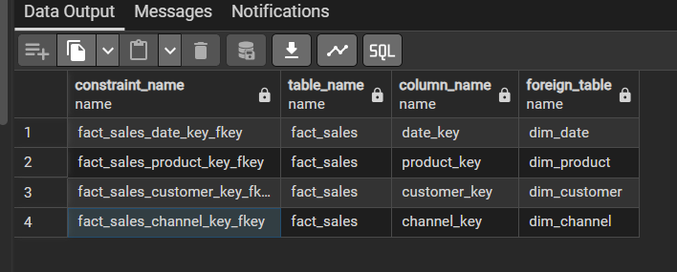

- Design the Physical Schema in PostgreSQL
CREATE TABLE dim_date (
date_key SERIAL PRIMARY KEY,
full_date DATE NOT NULL,
day INT,
month INT,
year INT
);
CREATE TABLE dim_product (
product_key SERIAL PRIMARY KEY,
product_id VARCHAR(10),
product_name VARCHAR(100),
category VARCHAR(50),
start_date DATE,
end_date DATE,
is_current BOOLEAN
);
CREATE TABLE dim_customer (
customer_key SERIAL PRIMARY KEY,
customer_email VARCHAR(100)
);
CREATE TABLE dim_channel (
channel_key SERIAL PRIMARY KEY,
channel_name VARCHAR(50)
);
CREATE TABLE fact_sales (
sales_key SERIAL PRIMARY KEY,
date_key INT REFERENCES dim_date(date_key),
product_key INT REFERENCES dim_product(product_key),
customer_key INT REFERENCES dim_customer(customer_key),
channel_key INT REFERENCES dim_channel(channel_key),
quantity INT,
revenue NUMERIC(12,2)
);
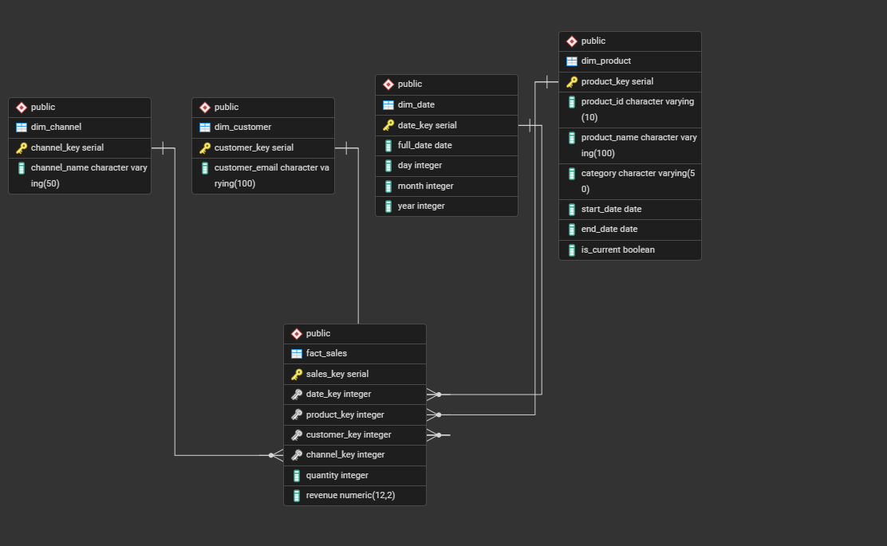

- Load the data, dimensions followed by fact table
INSERT INTO fact_sales
(date_key, product_key, customer_key, channel_key, quantity, revenue)
VALUES (1, 1, 1, 2, 2, 2400);
SELECT
d.full_date,
p.product_name,
c.customer_email,
ch.channel_name,
f.quantity,
f.revenue
FROM fact_sales f
JOIN dim_date d ON f.date_key = d.date_key
JOIN dim_product p ON f.product_key = p.product_key
JOIN dim_customer c ON f.customer_key = c.customer_key
JOIN dim_channel ch ON f.channel_key = ch.channel_key;
